Curriculum Vitae

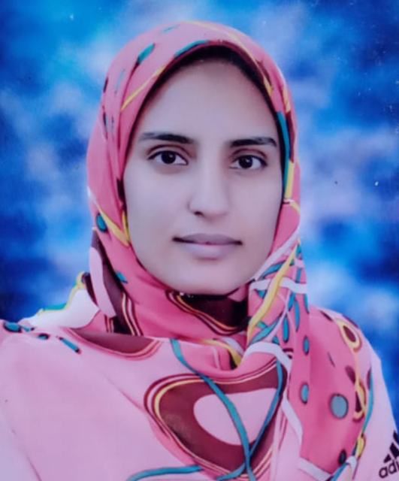
Name: Yasmine Faisal Mohamed
Date of Birth: 4/2/1996
Gender: Female
Religion: Muslim
Nationality: Egyptian
Address: Assiut, Egypt.
Contact Address: Department of Pharmacology, Faculty of
Pharmacy, Assiut University
E-mail: yasminefaisal8@gmail.com
Yasmine_Faisal@pharm.aun.edu.eg
Phone Number: 01069276027
Languages:
-Arabic is the mother language
-English is good
Academic Qualifications:
- Bachelor in Pharmacy, Faculty of Pharmacy, Assiut University in 2019. Excellence with honor
- Demonstrator at Pharmacology Department, Faculty of Pharmacy, Assiut University.
Grade:
Demonstrator at Pharmacology Department Faculty of Pharmacy, Assiut University.
Computer Skills:
1- Microsoft Office.
2- Molecular Operating Environment.
3- Chemdraw.

